A Message From Mars
In 1913 cinema was still a very young form of entertainment. The first public performances of moving image shows had been held just 18 years before in 1895. The Lumiere’s short comic film L’Arroser Arrose screened in that year also prompted a second major cinematic first, namely the first use of a poster to promote the performance. Unfortunately, there does not appear to be a surviving poster for A Message From Mars – perhaps one was not produced, but there is a ‘Souvenir’ which one presumes was sold to people in the same way programmes for plays are available to theatre-goers to buy today. A Message From Mars was a famous play after all, so the fact a ‘souvenir/programme’ was produced is perhaps not surprising.
TASK
What are the different elements that make up the cover of the “souvenir”?
Who is given prominence on the cover?
Why do you think the drawing is included?
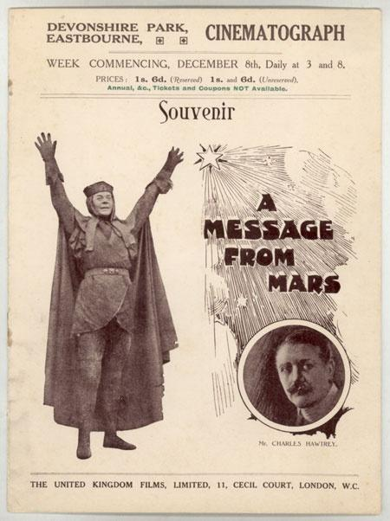

You should now try to create your own poster for the film. There are a number of images that you can use from the “paratext section of the website
Try to include some ‘grabbing’ strap-lines to emphasise the film’s more sensational aspects:
‘See the selfish brute beat up a flower seller!
“No Christmas dance for me – leave me alone to read my book!”
‘Escape is not an option when Martians command you to walk backwards!’
You should also include factual information about the screenings which can be taken from the souvenir copy.
Message From Mars – Science Fiction or not?
Although the idea of genre was centuries old - dating back to the Ancient Greeks who distinguished Comedies and Tragedies – the establishment of the kinds of conventions that we associate with modern-day film genres was only just beginning in 1913 when A Message From Mars was made.
That said, A Message From Mars is frequently referred to as the UK’s first Science-Fiction film.
TASK
Come up with as full a list of the kinds of events, props, actions and outcomes that you associate with Science Fiction films. To what extent does A Message To Mars contain these elements or not
Message From Mars - Narrative
A Message From Mars was an hour long and came in four parts or reels that needed to be threaded onto a projector or separate projectors so that the film’s showing was not interrupted. In 1913 a film of this length was a novelty and the fact that the audience could follow the narrative was a sign of its growing sophistication.
TASK
Discuss the following and decide which you feel has the most important job to do in the film in order to help the audience understand what is going on.
- The use of ‘intertitles’ explaining in words what is happening or about to happen or what a character is saying at any given time.
- Intercutting - the sudden jump from one setting to another in order to suggest actions and events happening in parallel or events occurring later in time.
- Analytical editing – the use of different kinds of framed image to highlight events or emotions or significant incidents that occur during a particular scene – the move, for example, from a long shot of a room to a close up of a cat about to knock over an ornament.
- Continuity editing - the movement of a character from one space to another in such a way that we grasp that the character has shifted their ground but in a way that is meaningful and not just mystifying. This is particularly important when depicting ‘chases’ in films or moments of dramatic action.
- Split screen sequences involving scenes that are happening in parallel but which share the screen at the same time.
Identify moments when the narrative requires an understanding of these kinds of ‘conventions’ to be comprehensible.
Are there things that remain mystifying in terms of the details of the story despite all these narrative techniques? For example, does it matter that the film does not explain Ramiels crime to us or the significance of the confiscation of the Ankh symbol from around his neck or the loss of his costume with the lion claw should adornments?
Is it clear to anyone watching the film that the Charles Hawtrey character is too absorbed reading about the latest scientific theories concerning Mars to go to the Christmas Eve dance with his fiancé? (Perhaps the audience was being relied on to draw on their knowledge of the play for this detail?)
Is it clear what Hawtrey’s fiancé is saying to and feeling about her male admirer at the dance?
Message From Mars - Mise En Scene
Mise en Scene refers to the fact that careful choices are made (or should be made) by filmmakers about the things that appear in each scene of their films. Everything should contribute to the atmosphere of the film or perhaps suggest something about a character.
- Study the opening brief sequences in which we are introduced to the cast. Are there any indications of the kind of people the actors are about to create for the film that can be spotted in their surroundings, costumes and behaviour?
- Study the two following images showing Charles Hawtrey in his sitting room and Minnie and Aunt Martha in their home. How do these settings suggest the different genders of the characters and their possible attitudes to life?
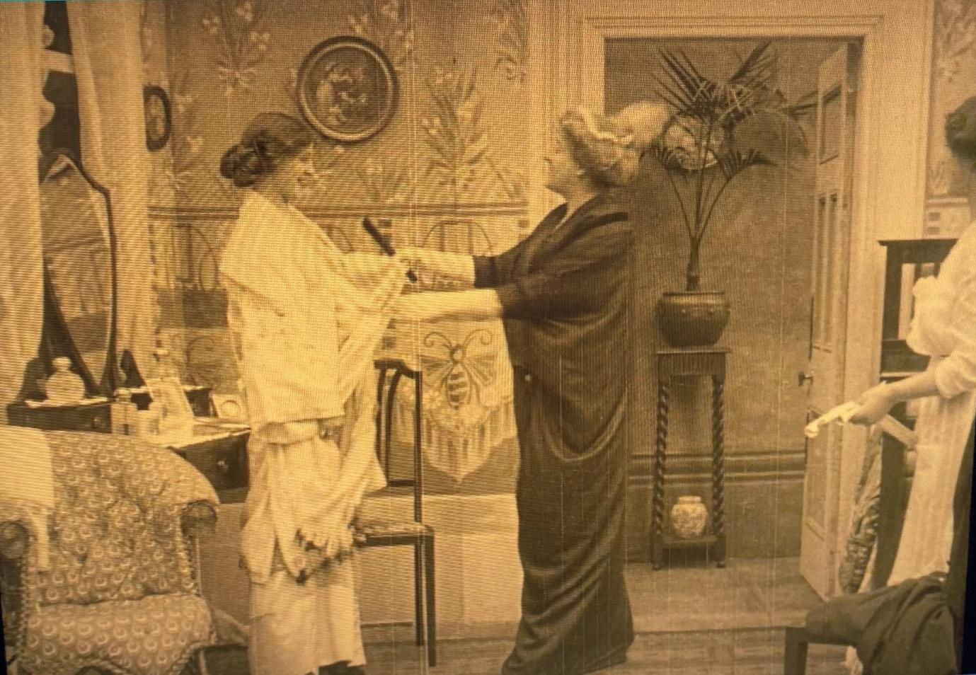

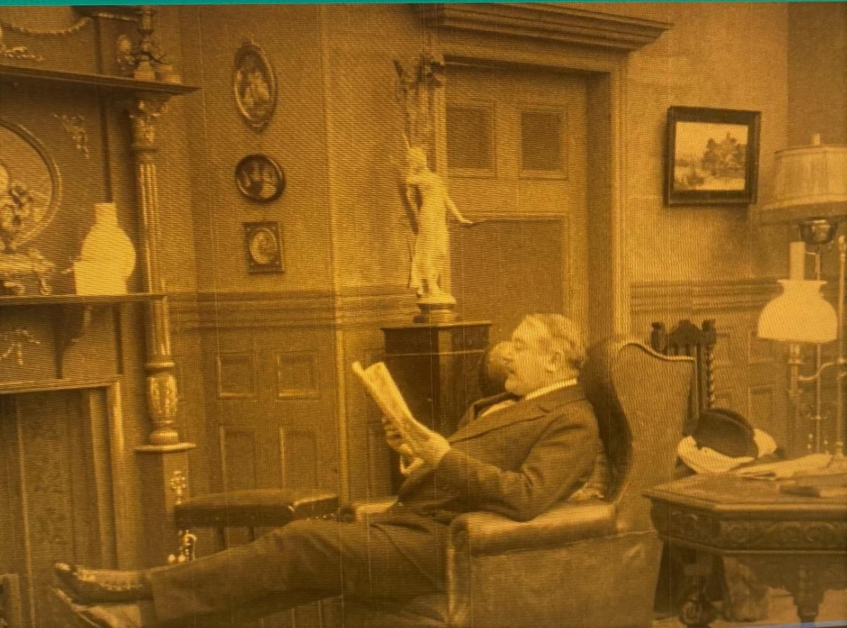
And what of the Martian world? How is it presented and what clues does the Mise en Scene convey about the Martians and their society?
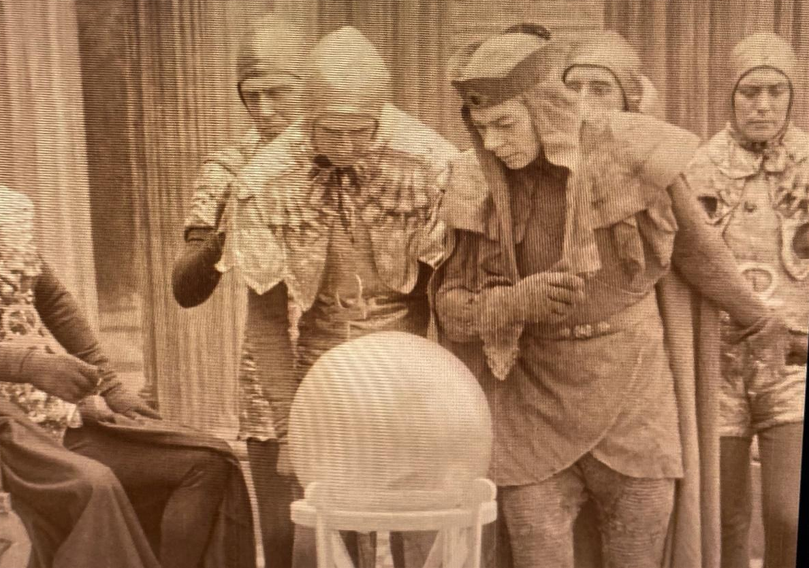
Message From Mars – The Moral
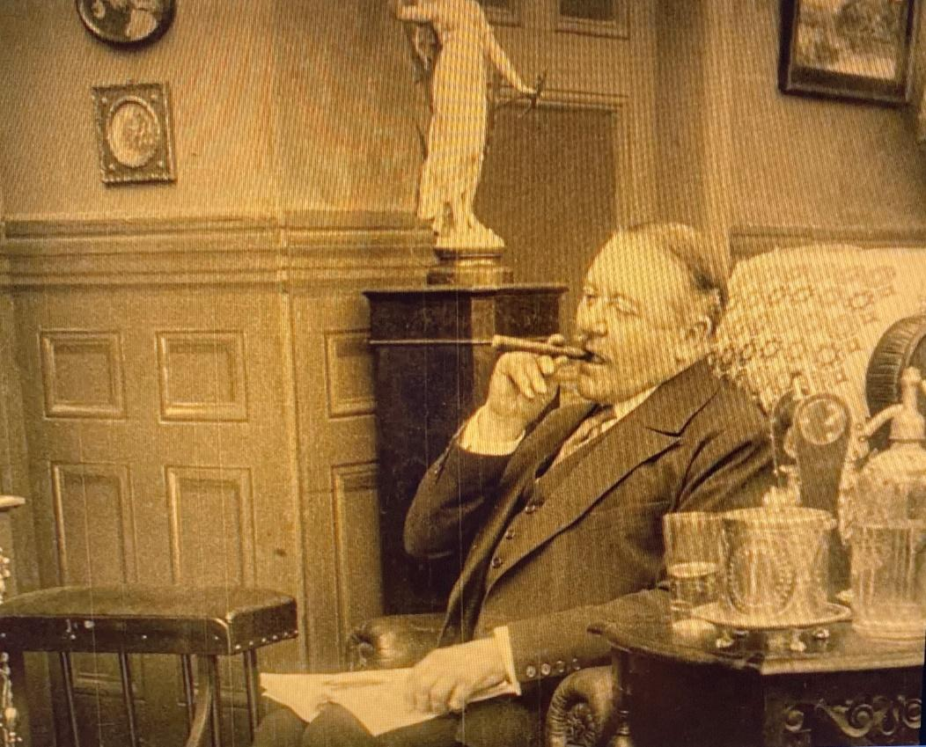
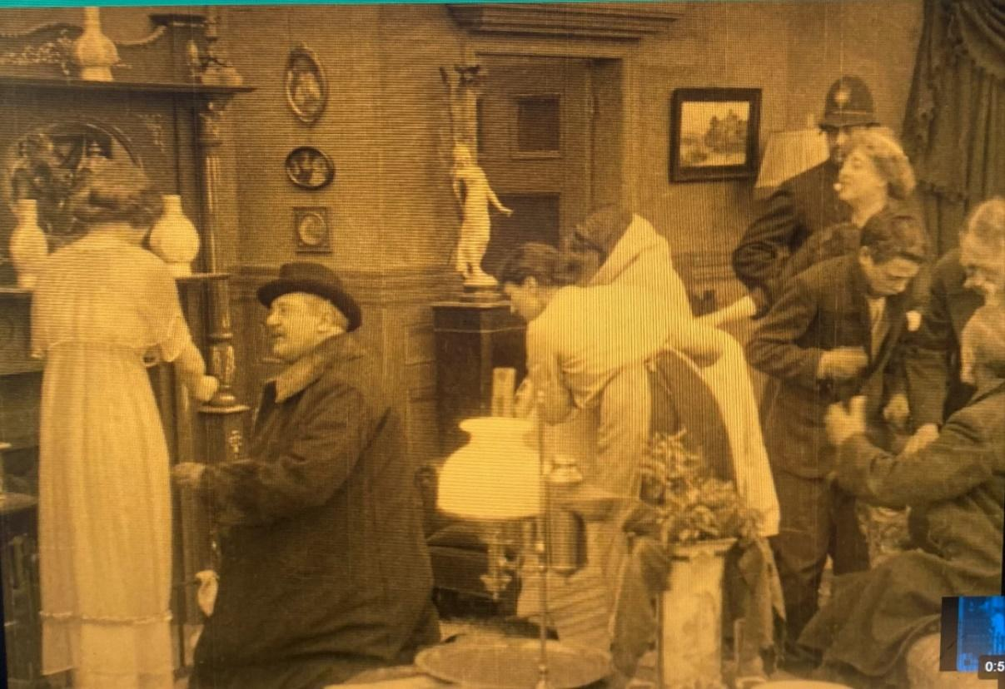
At the heart of A Message From Mars is the narrative arc – or journey – that the Charles Hawtrey character Horace goes on. Discuss how these two shots ‘capture’ the message of the tale and his protagonists’ personal development?
Supplementary materials
As this teaching resource is written there are no less than two ‘rovers’ exploring the surface of Mars. Both the US and Chinese vehicles managed to reach the planet’s surface despite its thin atmosphere which makes a controlled rather than a crash-landing so hard to achieve. The American Perseverance Rover has also deployed a helicopter called Ingenuity which has managed a remotely operated flights – a first! There have been some spectacular and important sights too including strangely coloured cloud formations and evidence of wind and water effects on the rocks and surfaces in the Jezero Crater where Perseverance landed.
The one thing both Rovers have so far failed to detect is a race of strangely attired god-like beings, living in what looks like a mock-classical colonnaded spa, and with a particular concern for the behaviour of individual earth-people.
But that’s where the 1913 silent film Message To Mars comes in….
This recently rescued and restored gem had been celebrated as one of the UK’s first long narrative films and also the country’s first Science Fiction film. These materials will examine both claims as well as restoration process and the creation of its new soundtrack.
But first, what is it about Mars that has always excited human beings’ imaginations, desires and fears – emotions that were definitely at play when A Message From Mars was made.

Activity 1: What is it about Mars?
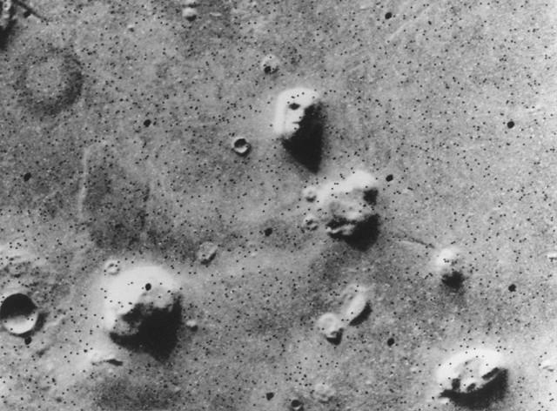

This image shows a small part of the Cydonia region of Mars, taken by the Viking 1 orbiter and released by NASA/JPL on July 25, 1976. It sparked a lot of interest because it seemed to reveal a distinctly humanoid-shaped rock formation which some felt had to have been carved deliberately: evidence that intelligent life may once have existed on the planet. (In case permission to include this image is unobtainable, here is the link: Martian face Viking cropped - Cydonia (Mars) - Wikipedia
Invite students to conduct your own online research to discover what later space missions to Mars established about this strange phenomenon. In doing so, encourage them to investigate the term ‘pareidolia’ and see if they can find other examples.
This is a good place to start because the capacity of the mind to play visual tricks on us lies at the heart of film thanks to ‘persistence of vision’. Again, this is a good subject for students to pursue via on-line research.
Creating a living Mars and Mankind timeline. The following details will help fill in students’ background knowledge about humanity’s centuries’ old curiosity about Mars. The list of facts is rather dry, but one way to lift it; making it fun and memorable is to embody each of the details with students creating small tableau or mini-dramatic scenes. The heavy-lifting for this task rests with the teacher in the first instance: calling for volunteers; stating the ‘fact’ and instructing students to create a particular tableau to show the rest of the class. The important thing is speed.
(For example: to ‘capture’ the first detail, all that is needed is a student turning slow circles while holding up four fingers. The second might be embodied by a student pointing to their eye and holding up a paper on which is written ‘45 million’. Nothing more complicated is needed. Having created four or five such ‘pictures’, then quickly run through them inviting the rest of the class to call out what they mean. In the end, the full list can be dramatized. Occasional revision of these details can be achieved by asking students to repeat their representation later in any teaching session or on other days.)
- Mars is the ‘fourth rock from the sun’ – in other words it is the fourth planet in our solar system orbiting the Sun.
- Mars is the closest planet to Earth and can be observed with the naked eye. It is half an Astronomical Unit (AU) from the Earth or about 45,000,000 miles. AUs are what astronomers use to measure the immense distances they need to describe.
- Mars is known as the ‘Red Planet’, due to the brownish-red colour of its surface caused by iron oxide in the soil. And being seen as red had led early people to give the planet extra meaning: associations with blood, anger and war.
- It is possible to detect changes occurring on Mars with the naked eye and that added to the sense of the planet as a dynamic environment – most likely populated. Now these changes are correctly attributed to dust storms and shifts in the polar ice caps, but once they suggested some intelligence at work.
- Because of differences between our orbit around the Sun and that of Mars, it sometimes appears that the planet reverses its direction of travel in the night’s sky. It was because of this and other observations that it was realised the planets revolved around the Sun and not Planet Earth, which had been the official teaching for centuries. It revealed we live in a Solar system rather than Geocentric one.
- Mars gets its current name from the Roman god of war; however, it went by other names in different cultures. To the people of ancient China, it was known as the “fire star”, ancient Sumerians believed that Mars was Nergal, the god of war and plague, it was referred to in Mesopotamian texts as the “star of judgment of the fate of the dead”. The Greeks knew it as Ares, their god of war. (Source: All About Mars - RocketSTEM)
- The first person to observe Mars through a telescope was Galileo Galilei in 1610.
- In the 1830s the early astronomer John Herschel (1792-1871) asserted that it was inconceivable that the Universe with its myriad planets and stars would not be populated by more than just us on planet Earth.
- In 1877 observations by the Italian astronomer Giovanni Virginio Schiaparelli of lines on the surface of Mars stimulated a fever of speculation about the possibility of intelligent life on the planet. This was mainly due to the mis-translation of the Italian ‘canali’ meaning channels as ‘canals’ – a word that suggested deliberate design. From there others speculated that the Martians were attempting to use these canals to move water from the poles to the arid majority of the planet – Mars was thus assumed to have an environment in crisis.
- The writer H.G.Wells writes his famous novel The War Of The Worlds in 1897 in which Martians invade the Earth in the hope of making it a new home given their own was doomed.
- In November 1899 the play A Message From Mars written by Richard Ganthony opened at the Royal Avenue Theatre near Trafalgar Square in London. (Trafalgar Square is the first earthly location we see in the film.)
- A Message From Mars was a very successful play. Two years later, following a very run of more than 500 performances in London, the play and its star performer, Charles Hawtrey, transferred to New York's Garrick Theatre. Between 1903 and 1905, Hawtrey's theatre company took the play on tour throughout the United States.
- In 1913 Charles Hawtrey adapted the role he had played on stage for the film version of A Message From Mars.

